**P7-Yong Deng outputs:**

**Screen shot of P7 at start:**

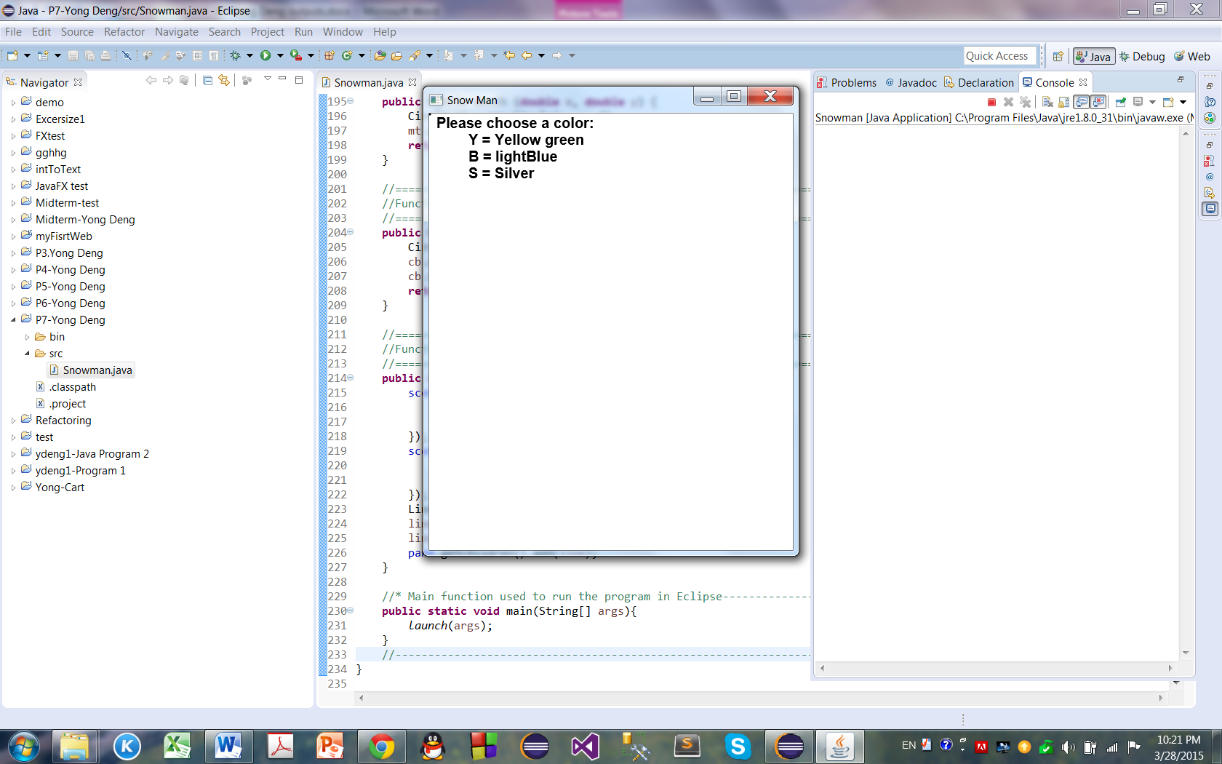

**Screen shot of P7 at Complete:** 